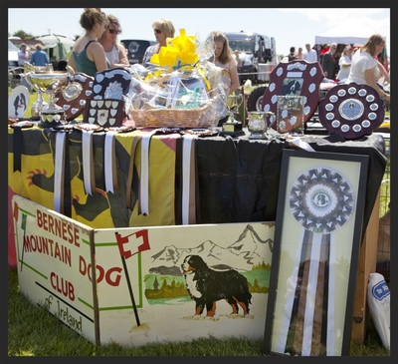
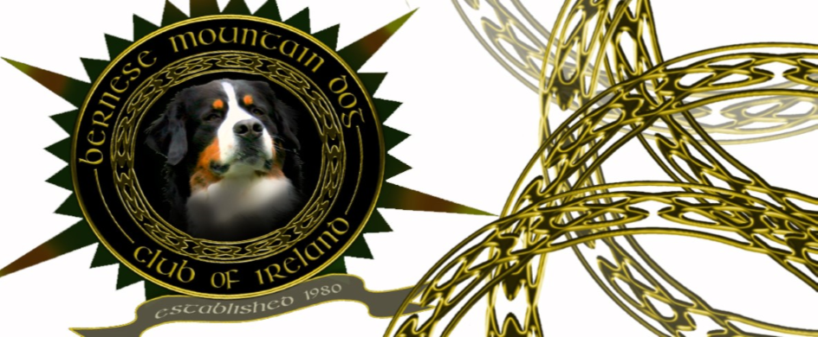

Bernese Mountain Club of Ireland Breed Specialty

Sunday 16th June 2019

The Bernese Mountain Dog Club of Ireland Breed Specialty will take place on Sunday 16th June 2019 at the Irish Kennel Club National Show Centre at Cloghran, beside Dublin Airport.
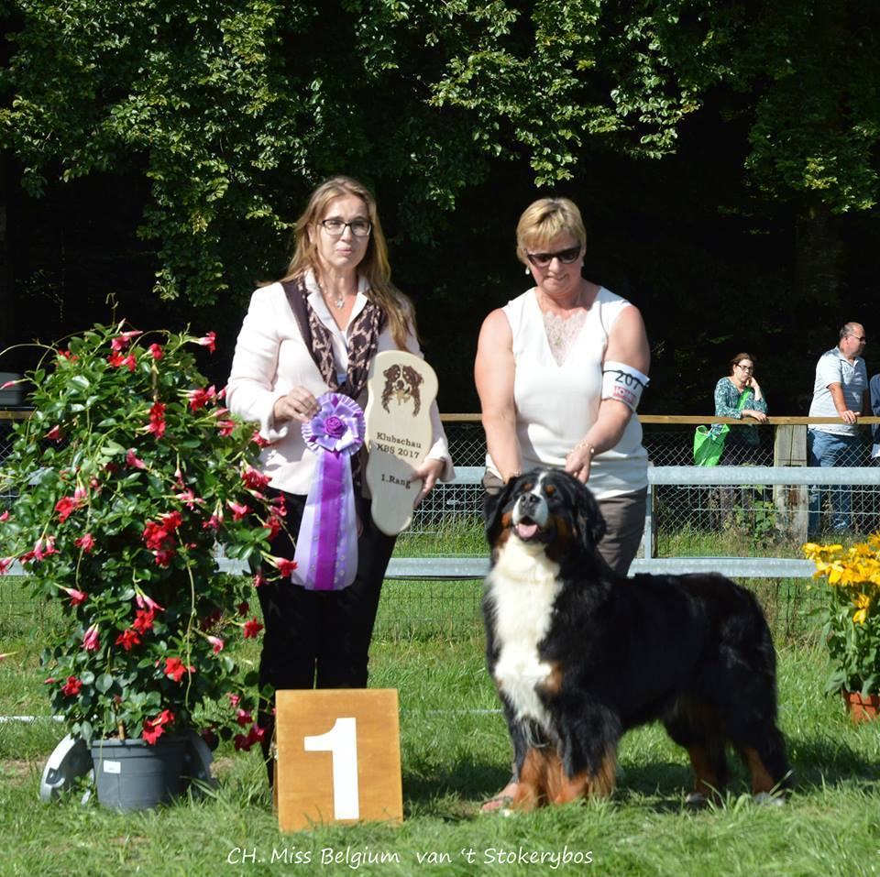
The Judge for this year is Breed Specialist Jana Stefancova from Slovakia. Jana has owned Bernese Mountain Dogs since 1992 and her Kennel name is Balihara Ranch. Dogs from her breeding have World Winner Titles, European Winner Titles, she has had Multiple International Champions and Champions across the world. Jana served as President of the Slovakian Club for Swiss Mountain Dogs for many years and was awarded the Bronze Medal of Merit in 2014 and the Silver Medal of Merit in 2018 for her work in the Canine World.
Jana judged the Swiss Breeds at the European Show in 2016 and has judged the breed at National Level and at Specialties in Belgium, Slovakia, Russia, Sweden, Denmark, Norway, Poland, Czech Republic, Latvia, Lithuania, Estonia, France and in Switzerland. We welome Jana on her first visit to Ireland.
There will also be the opportunity for exhibitors to compete for a second set of Green Stars on the same day as the BSD Group 1 & 2 Championship Show takes place and the judge for Bernese Mountain Dogs is Jan Counotte from Belgium. The previous day is Swords All Breed Championship Show and the judge for Bernese is Fernando Quilis Bonet from Spain.
There are also classes for Novice, Beginner and Junior handlers so an opportunity for all to come out and show off their beloved Bernese.
SCHEDULE ONLINE ENTRY AND POSTAL ENTRY DETAILS WILL BE AVAILABLE VERY SOON ON WWW.DOGSHOWENTRY.IE

